|  |  |
| --- | --- |
| Team ID | PNT2022TMID16931 |
| Project Name | Project – News Tracker Application |
| Maximum Marks | 8 Marks |

**SETTING UP APPLICATION ENVIRONMENT**

**CREATE AN ACCOUNT IN SENDGRID**

**STEP 1 : Go to the official sendgrid website then click start for free**

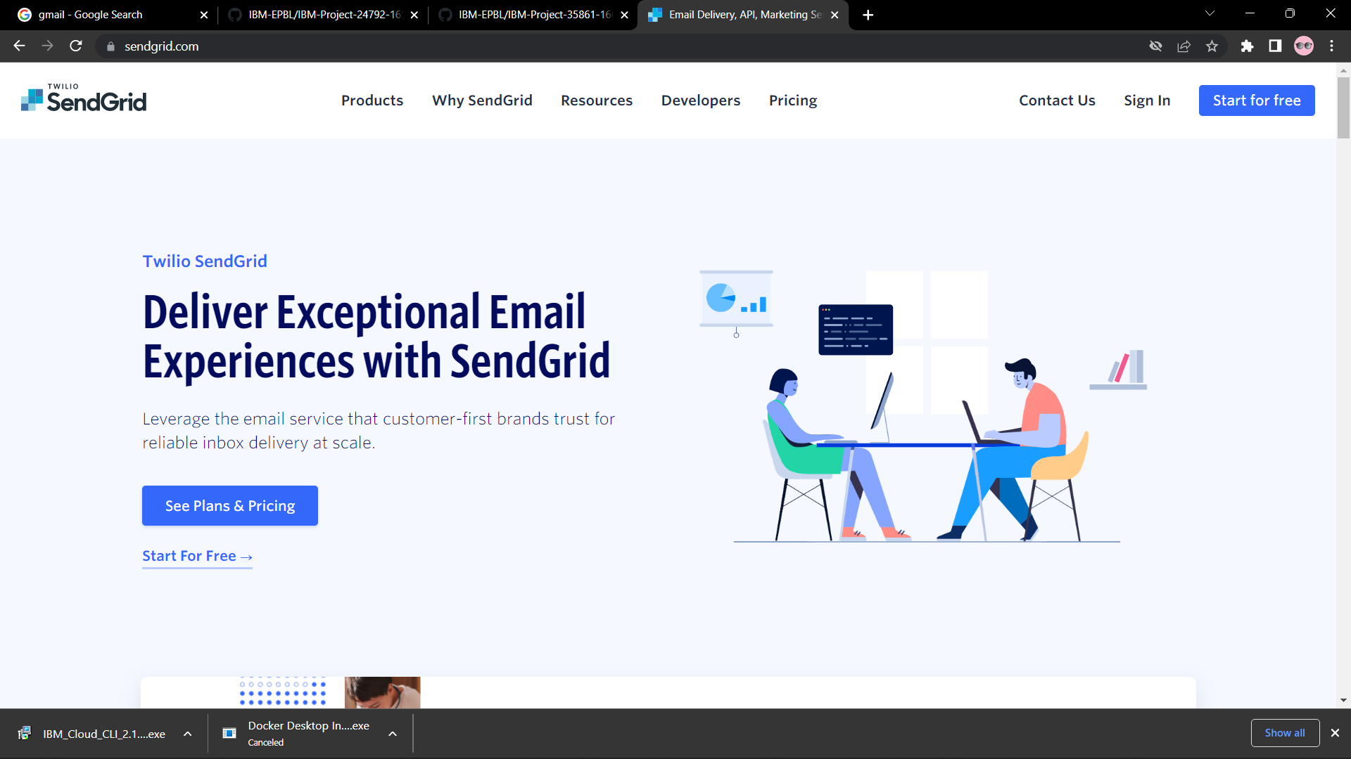

**STEP 2 : Then go the register page and give all the details required to create a account and finally click on create button.**

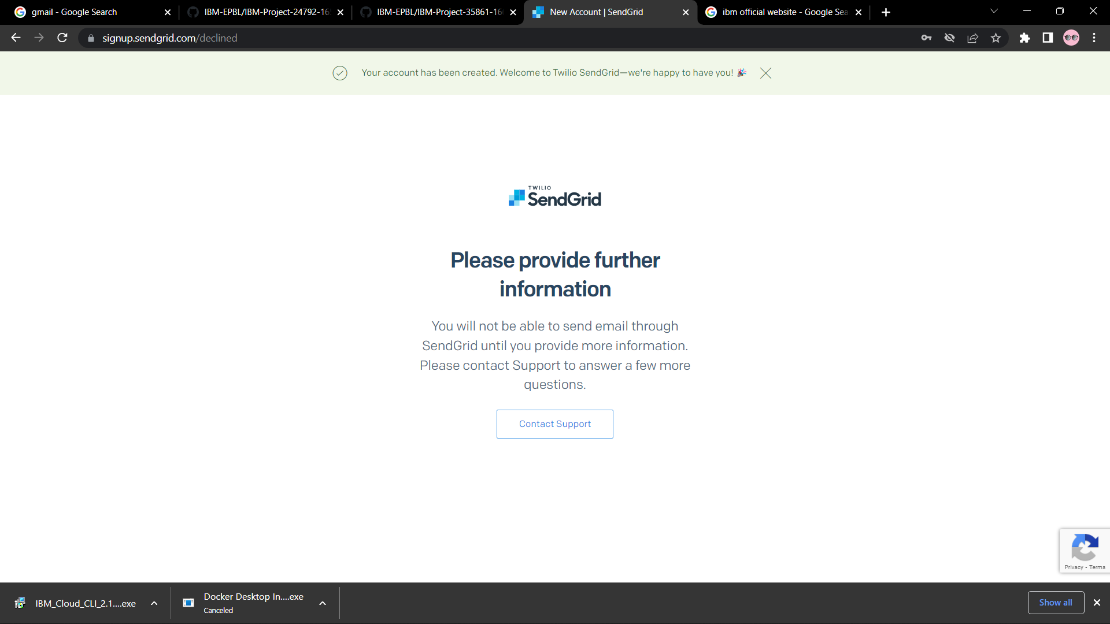

**STEP 3 : Finally you have created your account successfully.**